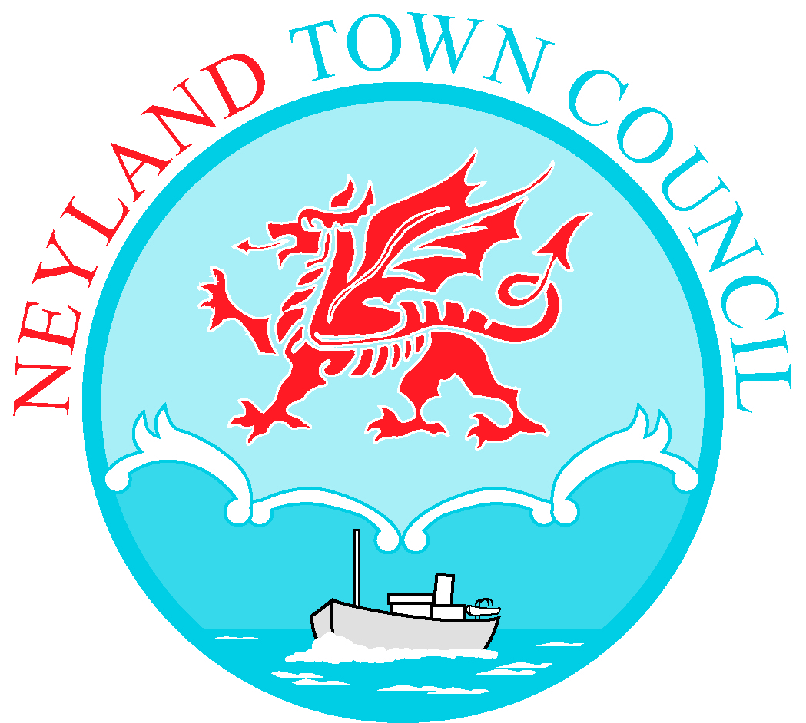

TO: All Members of Neyland Town Council 2nd August 2023

Dear Councillor,

You are hereby summoned to attend an Extraordinary Meeting of Neyland Town Council to be held on Monday 7th August, at 7.00pm at Neyland Community Hub. If you require a link to attend the meeting virtually, please email townclerk@neyland.org.uk

Yours sincerely,

Libby Matthews
Town Clerk

AGENDA
- To receive apologies for absence.
- To receive Declarations of Interest from Members regarding the business to be transacted.
- Recording of meetings policy. Cllr B Rothero
- To reconsider minute number 4130. Cllr B Rothero
- To appoint Members to external Committees, Groups, Boards, etc.
- Christmas lights consultation, to report decisions made by working group. Cllr S Thomas
- Staff training and development. Cllr S Thomas
- Payments to be approved.
- Clerk’s report.
- Mayor’s update.
- Deputy Mayor’s update.
- Exchange of information at the discretion of the Mayor.
- Date of next meeting: 4th September 2023 at 7.00pm.

