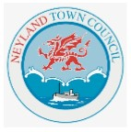 | Easter Quiz/Trail Questions 2025:  Running from Wednesday 16th to Wednesday 23rd April.  Senior Quiz; for children of all ages.  No prizes, just the satisfaction of taking part.

Please enjoy. Take your time, you have several days to complete. Guess or work-out your answers, looking things up ‘on-line’ isn’t as much fun.
Write the question answers on these sheets. There are additional picture questions, marked ‘Senior Quiz’ in windows around the Town, see list below.
(There is a Junior Quiz/Trail running at the same time, in same windows.)

The Town Council will post the answers to this Quiz after the Easter School Holidays, on its’ website, on its’ Facebook, in its’ noticeboards.
Look out to see how well you did, after Wednesday 23rd April.

(All answers were correct, as far as the question writer knew, at the time of printing. He did his best.)

Picture Clues At ( in the window of ):-

1) – Neyland Library / 2) – Paul Sartori Charity Shop
3) – The Plaice To Eat 4) – Morrisons Daily / 5) – Old Paper Shop 6) – Foxgloves Florists / 7) – Co-op Store

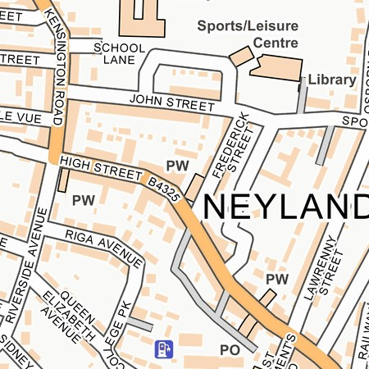

Now turn over this page and begin the Quiz/Trail.

Answers Sheet no. 1

Picture no.1 -- Neyland Library Window.
How many Easter eggs are sold in the UK every year?

Which country started the tradition of the Easter bunny?
United Kingdom / Germany / Italy / France?

When do Easter Egg Hunts traditionally take place?
Christmas Day / Easter Sunday Morning / Halloween?

Picture no. 2 – Paul Sartori Charity Shop Window.
What hat is traditionally worn by ladies at Easter?

A popular myth is Easter was named after?
A rabbit called Easta?
Eostre, an Anglo-Saxon Goddess?
My Aunty Elsie?

Which religion celebrates Easter?
Christian / Buddhist / Islam / Sikhism?

According to the Weather Service, what weather are we more likely to see at Easter than at Christmas?
Snow / Rain / Sunshine / High Winds / All Four?

Picture no 3 – Chip Shop (The Plaice To Eat) Window.
In which Ocean is Easter Island?

In the UK, what is the most popular way of cooking eggs. (Not chocolate ones.)
Boiled / Fried / Scrambled?

In the Bible, how much time passed between Jesus' death and resurrection?
Three Hours / Three days / Three Weeks?

Answers Sheet no. 2

In what season of the year does Easter take place in Australia?
Spring / Summer / Autumn / Winter?

Picture no. 4 – Morrisons Daily Window.
Children in Finland dress as what at Easter?

Before Easter, on what day do we eat pancakes?
Valentine’s Day / Shrove Tuesday / Any day is good?

Who wrote ‘The Tale of Peter Rabbit’?
Beatrix Potter / J K Rowling / Julia Donaldson?

What Easter present is said to bring good luck for the rest of the year?
(Children often have too many chocolate eggs, they may get what instead.)
New Cloths / Pair of Shoes / Electric Scooter?

Picture no. 5 – Old Paper Shop Window.
In Switzerland, what animal delivers Easter eggs to children?

What roast meat is traditionally consumed on Easter Sunday?
Turkey / Chicken / Lamb / Beef / Pork?

Which jeweller decorated Easter Eggs for the Russian Royal Family?
Faberge / Pandora / Samuels?

Answers Sheet no. 3

What type of bun is traditionally eaten at Easter?
Jam and Cream Scone / Doughnut / Hot Crossed Bun?

Where would you find the world’s largest Easter Egg?
Belgium / Canada / Japan / Kuwait?

Picture no. 6 – Foxglove Florists
What is the official flower of Easter?

Which country grows the most daffodils?
United Kingdom / Holland / Belgium?

The first Easter Eggs were painted what colour?
Blue / Green / Red / Yellow / Orange?

Picture no. 7 – Co-op Store
Rabbits with long floppy ears can’t hear as well as those with upright ears?

