

**Neyland**

**Town**

**Council**

**2022/23**

NTC Town Improvement Committee

Version 6

January 2022

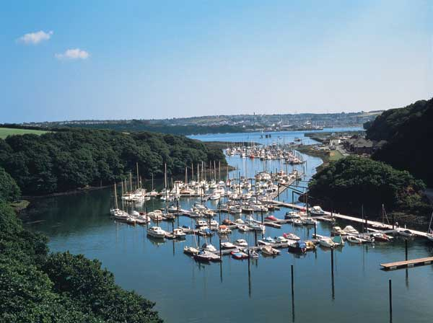**Office use only**

Improvement Grant Application Form

**Reference No:**

**…………………….**

**Date of receipt:**

**…………………….**

**About Your**

**Organisation**

Please complete and return this application form to;

**Town Clerk, Neyland Town Council**

**Council Offices**

**54 High Street, Neyland**

**Pembrokeshire SA73 1TF**

Applications will be reviewed on a monthly basis and applications received on or before the last working day of the month will be assessed in the subsequent month.

**Please ensure you have read the Guidance notes! Good Luck**

**Organisation Name:**

**…………………………………………………………………………………………..**

**Address:**

**……………………………………………………………………………………………**

**……………………………………………………………………………………………**

**Project Lead Contact Details:**

**Name: ……………………………………………………………..**

**Address:**

**………………………………………………………………………………………..**

**…………………………………………………………Post Code……………..**

**Email: ………………………………………………………………..**

**Contact Telephone:…………………………………………….**

**Please confirm that your activity either takes place within the Neyland Town Council Wards of Neyland East and West or has a direct impact on the Neyland Population.**

I confirm the above

**About Your**

**Project**

**Project Financial Details**

Please affix supplementary sheets if you require more space

Notes;

Please breakdown the funding from other sources (an organisations own funds is a perfectly acceptable other source) and mark whether the funding is committed, applied for or a potential source once feeder money from this fund becomes available.

We are very aware that the 1st grant is the hardest to come by and are very happy to support projects currently without other funding to provide that initial boost. In these cases please indicate where you hope additional funds may come from.

**Please describe your project to us in 250 words or less.**

|  |  |  |  |  |  |  |  |  |  |  |  |  |  |  |  |  |  |  |  |  |  |  |  |  |  |  |  |  |  |  |  |  |  |  |  |  |  |
| --- | --- | --- | --- | --- | --- | --- | --- | --- | --- | --- | --- | --- | --- | --- | --- | --- | --- | --- | --- | --- | --- | --- | --- | --- | --- | --- | --- | --- | --- | --- | --- | --- | --- | --- | --- | --- | --- |
| |  |  |  |  | | --- | --- | --- | --- | | **Item Description** | **Cost £** |  |  | |  |  |  |  | |  |  |  |  | |  |  |  |  | |  |  |  |  | |  |  |  |  | |  |  |  |  | |  |  |  |  | | **Total Project Cost [A]** |  |  |  |   **Funding From Other Sources** |  |
|  |  |
|  |  |
|  |  |
|  |  |
|  |  |
|  |  |
| **Total Funding From Other Sources [B]** |  |

|  |  |
| --- | --- |
| **Total Grant Sought from this fund [B – A]** |  |

**Project Outcomes**

Estimates are acceptable however you may be asked to elaborate later.

Note;

Showing growth is not a requirement of a grant. Please do not be afraid to tell us that you do not envisage a growth in membership / users, if that’s the case.

Please insert supplementary sheets if you require more space.

You should take particular care to include any benefits of your project that do not relate to increased users and give special mention to any benefits that will affect the town as a whole   
(as opposed to your current / proposed membership and users.)

Please confirm that you agree to complete a follow up form upon completion of your project 

Please confirm that to the best of your belief the ongoing viability of your organisation is not in question 

Please confirm that you will allow NTC access to your accounts, upon request, so they may satisfy themselves as to the above 

Please complete the projected new user data below.

|  |  |  |
| --- | --- | --- |
| **Membership / Users** | **Current(A)** | **Projected(B)** |
|  |  |  |
| **Directly Affected by Project – Senior Males** |  |  |
| **Directly Affected by Project – Senior Females** |  |  |
| **Directly Affected by Project – U16 Males** |  |  |
| **Directly Affected by Project – U 16 Females** |  |  |
| **Membership / Users not directly affected** |  |  |
|  |  |  |
| **Total** |  |  |

**Please tell us in your own words what you hope to achieve through this project and how you believe its success can be measured after completion. [250 words max]**

**Declaration and Terms and Conditions**

**Please read carefully.**

I have read and fully understand the terms and conditions above.

Signed ………………………………….. Date …………………………….

Print Full Name ……………………………..................................

Position in Organisation …………………………………………………

**We, the undersigned, on behalf of the applicant organization understand and agree that;**

* **We are authorised to complete this application on behalf of our organisation**
* **We have the power to accept any grant that may be awarded to our organisation, subject to the terms and conditions listed below and the power to repay the grant in the event of any grant condition not being met.**
* **All information submitted in this application is truthful and accurate and the Neyland Town Council Town Improvement Committee will be informed if there are any changes to this application or to the circumstances of the applicant organisation in relation to the grant being sought.**

**Terms and Conditions**

* **Any misleading, incorrect statement or fraudulent action or statement at any stage of the application process, whether deliberate or accidental, may render the application invalid and require the repayment of the grant in full.**
* **The grant will be used for the sole purpose set out in the approved application or as amended with the agreement of the NTC improvement committee and the applicant organisation.**
* **Any grant awarded is unlikely to be increased in the event of an overspend on the project. Any variation in support would be at the sole discretion of the improvement committee.**
* **The award must be acknowledged in any publication by the applicant organisation and failure to do so could exempt the organisation from further applications.**
* **All organisations awarded a grant must complete a project completion form within 8 weeks of the project completion date. Failure to submit such a form will render the applicant organisation ineligible to apply again.**
* **Any grant shall become repayable if, before the project completion form is approved the applicant organisation ceases to operate and or is declared bankrupt.**
* **NTC Improvement Committee reserves the right to audit any accounts relating to the project and will have the right to demand a refund if final expenditure and income differ significantly from the estimated figures.**
* **NTC Improvement committee also will have the right to demand a full refund where the applicant organisation fails to complete the project within a 12 month period unless otherwise agreed.**

I have read and fully understand and terms and conditions above.

Signed ………………………………….. Date …………………………….

Print Full Name ……………………………..................................

Position in Organisation …………………………………………………